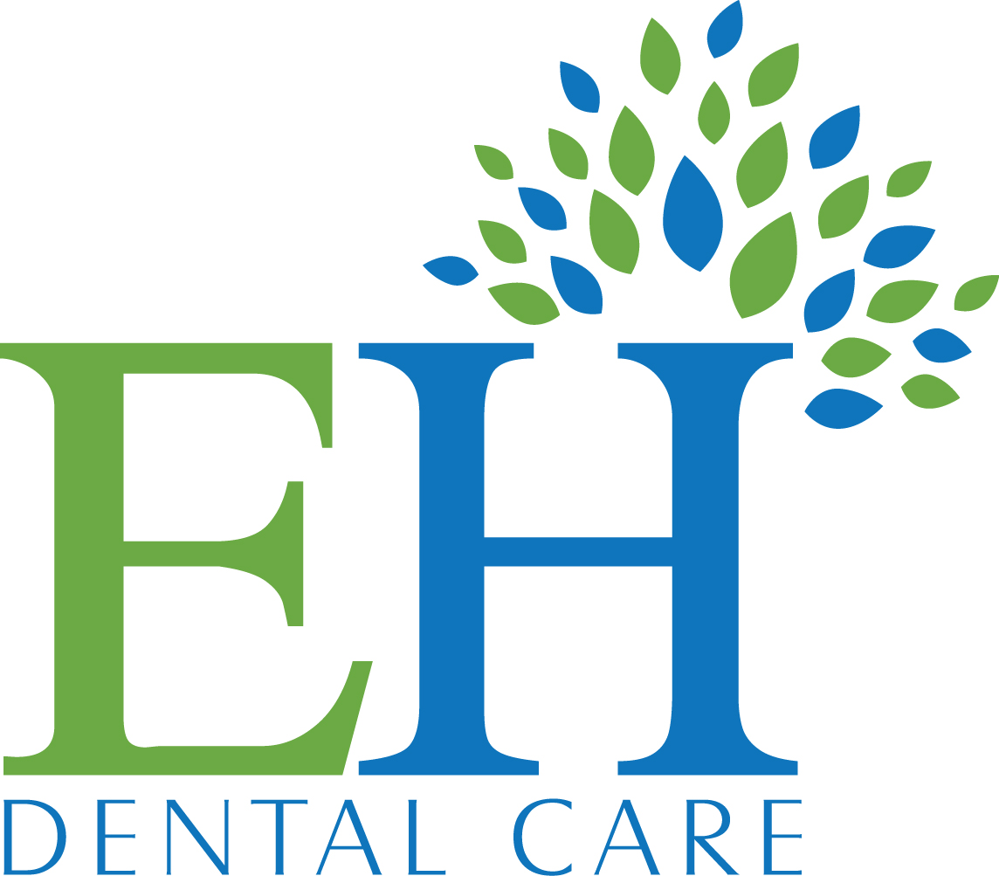
Welcome To EH Dental Care

Please complete all 4 pages as fully as possible.
If you are unsure of anything please do not hesitate to ask. This questionnaire is entirely confidential and no information you provide will be disclosed to a third party without your consent.

Title : -_______________ Forename(s) : -______________________

Surname : -______________________ Date of Birth : -______________________

Address : -__________________________________

__________________________________

__________________________________ Postcode : -_______________

Tel. (Home) : -___________________ Tel. (Work) : -___________________

Tel. (Mob) : -___________________ e-mail :-___________________
( please print your e-mail for clarity )

The NHS Requires Us To Collect The Following Information

Do you have to pay NHS Dental Charges? Yes □ NO □

If you do not have to pay all of your NHS dental charges please tick the box below that applies best to you.

*I or my partner has a current HC3 certificate for partial help with NHS Charges □
I am under 18 years of age □
*I am 18 years old and in full time education □
*I am pregnant □
*I have had a baby in the last 12 months □

I/My Partner receives
*Income support □
*Income Based Job Seekers Allowance □

I am/my partner is
*Entitled to, or named on a valid NHS tax Credit Exemption Certificate □
*I am/my partner receives Pension Credit guarantee credit □

*I have a current HC2 certificate for full help with NHS charges □

*If you have ticked any box with an asterisk above we are required to ask you for proof of your exemption status.

CONFIDENTIAL MEDICAL HISTORY FORM

Please circle the appropriate answer. If you answer yes to any questions please give details at the bottom of the page.

ARE YOU:
- Attending or receiving treatment from a doctor, hospital, clinic or specialist-------------------------- YES/NO
- Taking any tablets, creams, ointments, injections, etc from your doctor ------------------------------ YES/NO
- Taking now or within the last 2 years any creams or tablets containing a steroid------------------- YES/NO
- Allergic to any medicines, foods or materials ---------------------------------------------------------------- YES/NO

Are you an expectant mother ------------------------------------------------------------------------------------ YES/NO

HAVE YOU:
1. Had rheumatic fever or chorea (St Vitus Dance)------------------------------------------------------------ YES/NO
2. Had jaundice, liver, kidney disease or hepatitis------------------------------------------------------------ YES/NO
- Ever been told you have a heart problem such as angina, heart attack----------------------------- YES/NO
- Been treated for high or low blood pressure---------------------------------------------------------------- YES/NO
- Ever been treated with Bisphosphonate drugs - eg for osteoporosis-------------------------------- YES/NO
- Had a bad reaction to a general or local anaesthetic----------------------------------------------------- YES/NO
- A preference for any type of local anaesthetic-------------------------------------------------------------- YES/NO
- Had a joint replacement------------------------------------------------------------------------------------------ YES/NO
- Ever had any form of brain surgery--------------------------------------------------------------------------- YES/NO
- Any family members who have CJD (Creutzfeldt-Jakob Disease)------------------------------------ YES/NO
- Have you ever received Human Growth Hormone-------------------------------------------------------- YES/NO
- Been hospitalised-------------------------------------------------------------------------------------------------- YES/NO
- Been treated for cancer------------------------------------------------------------------------------------------ YES/NO

DO YOU:
- Have arthritis------------------------------------------------------------------------------------------- YES/NO
- Have a pacemaker, or have you had any form of heart surgery-------------------------- YES/NO
- Suffer from hay fever, eczema or any other allergy------------------------------------------ YES/NO
- Suffer from bronchitis, asthma or other chest condition------------------------------------- YES/NO
- Suffer fainting attacks, giddiness, blackouts or epilepsy------------------------------------ YES/NO

Have diabetes or does anyone in your family have diabetes------------------------------ YES/NO
- Bruise easily or have you bled so much as to cause you to be
worried following tooth extraction, surgery or injury----------------------------------------- YES/NO
- Carry a medical warning card--------------------------------------------------------------------- YES/NO

Are there any other aspects about your health that you think we should know about YES/NO

Please note your doctor’s name and address. ______________________________________

Name and contact telephone number of an immediate family member in case of emergency

__________________________________________________________________________

Signed (patient/parent/guardian) …………………………………………. Date…………………….…

If you answered YES to any question above please give details here

/ continued overleaf

1. Is there a particular reason for your visit today?

- How do you usually feel before visiting the dentist?
Not at all anxious□ Slightly anxious□ Fairly Anxious□ Very anxious□ Extremely Anxious□

2a If you feel anxious about your visit, what is it that worries you most?

3 How often do you usually attend the dentist?
Every 6 months □ every year □ every few years □ only when in pain □

4. Concerning Smoking or Tobacco use, which category best represents you?
Non-Smoker □ I smoke _______ cigarettes per day
I use a tobacco vapouriser ( Vape ) □

5. How many units of alcohol do you consume in a week?
0 □ 1-5 □ 5-10 □ 10-20 □ 20-30 □ 30+□

6. What is your occupation?
 |  | Yes | No
Are your teeth ever sensitive to hot, cold or sweet? |  | □ | □
Does food wedge between any of your teeth? |  | □ | □
Do your gums bleed easily or feel tender and irritated? |  | □ | □
Are you concerned about bad breath or a bad taste in your mouth? |  | □ | □
Would you like to have a conversation about the colour of your teeth? |  | □ | □
Would you like to have a conversation about the shape or position of any of your teeth? |  | □ | □
Which of the following do you use every day?
□fluoride toothpaste □Mouthwash, □Fluoride tablets or drops
□Dental floss □Sugar free Gum □ Not Applicable

We provide reminders of your appointments by e mail or sms text message, which would you prefer?
I prefer E-mail reminders □ Test message reminders□

How did you hear About the Practice? ___________________________________________

Please tell us about any members of your family that you would like to reserve a membership space in the practice for. Here

Would you like to register with the Medical Practice as well as the Dental Practice Yes□ NO□

Thank you, for taking the time to complete this questionnaire

Terms and Conditions ( Practice Copy )

We are passionate about great dentistry. We believe in being open and honest about what we do. Most of all EH Dental is about people so we hope you love the time you spend here with us………….

Lets Work Together…
We welcome patients of all ages and do our utmost to provide great dental care
We provide quality NHS dentistry and more aesthetic private treatments if you wish
You remain registered with us for as long as you want
All that we ask is that you attend for your appointment at the agreed time
Pay any charges for treatment on the day that treatment is received
and let us know in advance if you cannot attend your scheduled visit.

That’s it……..

The Small Print

Your Registration
An initial examination is free there may be a charge for x rays or other investigations
Assuming both you and your dentist agree a course of action, we will register you as a patient.
NHS Terms and conditions apply so your registration is for as long as you wish, but we do ask that you attend at the recommended intervals

Appointments
If you miss an appointment or cancel without 48 hours notice a fee of £20 is charged.
You will still have to pay this charge even if you are normally exempt from dental charges
You may lose your registration if you miss or cancel visits without adequate notice.

Payment
If you have to pay dental charges you will always receive an estimate before treatment starts
Payment is due on the same day that the treatment is provided

Problems
If you are unhappy with any part of our service please let us know
Please do this as soon as possible either in person, via a feedback from at reception or e-mail our practice manager on help@ehdental.co.uk

I have received and read a copy of EH Dental Care terms and conditions

Signed _________________ Date_____________

Terms and Conditions ( Your Copy )

We are passionate about great dentistry. We believe in being open and honest about what we do. Most of all EH Dental is about people so we hope you love the time you spend here with us………….

Lets Work Together…
We welcome patients of all ages and do our utmost to provide great dental care
We provide quality NHS dentistry and more aesthetic private treatments if you wish
You remain registered with us for as long as you want
All that we ask is that you attend for your appointment at the agreed time
Pay any charges for treatment on the day that treatment is received
and let us know in advance if you cannot attend your scheduled visit.

That’s it……..

The Small Print

Your Registration
An initial examination is free there may be a charge for x rays or other investigations
Assuming both you and your dentist agree a course of action, we will register you as a patient.
NHS Terms and conditions apply so your registration is for as long as you wish, but we do ask that you attend at the recommended intervals

Appointments
If you miss an appointment or cancel without 48 hours notice a fee of £20 is charged.
You will still have to pay this charge even if you are normally exempt from dental charges
You may lose your registration if you miss or cancel visits without adequate notice.

Payment
If you have to pay dental charges you will always receive an estimate before treatment starts
Payment is due on the same day that the treatment is provided

Problems
If you are unhappy with any part of our service please let us know
Please do this as soon as possible either in person, via a feedback from at reception or e-mail our practice manager on help@ehdental.co.uk

I have received and read a copy of EH Dental Care terms and conditions

Signed _________________ Date_____________

